

**P. E. Society’s  
MODERN COLLEGE  
OF**

**ARTS, SCIENCE & COMMERCE  
PUNE - 411005**

Department Of Computer Science

A

Project Report

On

‘ EventsNearMe ’

In partial fulfilment of requirement for the degree of

Masters of Science (Computer Science)

SUBMITTED BY

1) Namita Sonkamble ROLL NO.:1964050

2) shubhangi mahadik ROLL NO.:1964001

Under the Guidance of

PROF. Shamkant Deshmukh

[2019-2020]

P. E. Society’s

**Modern College of Arts, Science & Commerce**

Shivajinagar, Pune – 411005

**Department of Computer Science**

***CERTIFICATE***

This is to certify that Mrs . **SHUBHANGI MAHADIK**

Roll No. **1964001** has successfully completed the Project entitled

**“EventsNearMe”**

Towards the partial fulfilment of the M.Sc. (Computer Science) curriculum of LAB-III during the academic year 2019-2018.

Date:

Vice-Principal & Head

Project Guide Department of Computer Science

**Examiners:-**

Name Sign

1) ________________ ______________

2) ________________ ______________

ACKNOWLEDGEMENT

It has been a great opportunity to gain a lot of experience in real time project, followed by knowledge of actually implementing various ideas in the project and testing them. It helped me to understand and deal with the real time problems that are incurred during the working of a project.

I want to thank all the people who helped me and would like to extend a special gratitude to our HOD and my project guide ,*Prof. Shamkant Deshmukh* for their patience and guidance through out the semester.

I would like to thank ma’am who helped me in choosing the topic of the project and encouraged me and provided extreme help to complete this project.

At last I would like to thank all those people who understood and appreciated the aim of the project and encouraged me to further keep developing such projects.

INDEX

|  |  |  |
| --- | --- | --- |
| **SR NO.** | **TITLE** | **PAGE NO.** |
| 1 | INTRODUCTION | 5 |
| 2 | PROBLEM DEFINITION | 7 |
| 3 | EXISTING SYSTEM | 9 |
| 4 | PROPOSED SYSTEM | 11 |
| 5 | SCOPE OF SYSTEM | 13 |
| 6 | ADVANTAGES OF SYSTEM | 15 |
| 7 | FEASIBILITY STUDY | 18 |
| 8 | IMPLEMENTATION | 20 |
| 9 | SYSTEM MODEL | 21 |
| 10 | ENTITY RELATIONSHIP MODEL | 23 |
| 11 | DATABASE DESIGN | 28 |
| 12 | UNIFIED MODELING LANGUAGE(UML) | 34 |
| 13 | INPUT/OUTPUT SCREENS | 49 |
| 14 | TEST CASES | 53 |
| 15 | CONCLUSION | 55 |
| 16 | BIBLIOGRAPHY | 57 |

PROBLEM DEFINITION

Meaning of word ‘Event’ :

“The use of method involving people witnessing happening within a capsule of time, for the purpose of communication of message.”

An event is a live multimedia package carried out with some special concept, modified to achieve the client’s objective.

Events in terms of social and cultural life :

In social and cultural life, an event refer to social gathering or activity , such as :

* A festival , for eg. Music festival
* A party , for eg. Birthday party
* Ceremony ,for eg. Marriage

EventsNearMe Management is a process of searching a focused event, executive events for customer. It involves visualizing concepts, planning , searching as per budgeting ,searching as per facilities , executing events such as wedding celebrations, parties, Birthday parties , Prize distribution , Reception ,etc.

The opportunity of helping customer those who wish to search the halls for particular event but they need to visit various website to search hall with their budget and for required facility or physically they need to go to visit the various halls places. EventsNearMe app will help customer to search the specific event hall with customers budget and customers required facilities by comparing various hall information, after comparison it will provide you sorted result , then till will easy for customer to select hall , they can view the hall images.

In our system there have several features like:

* Client Features :
* Online System
* Booking option
* Information about various Hall
* Company Features :
* Handling Database
* Provide Simplicity
* Provide Security
* Provide Efficiency
* Provide Easy Searching
* System Features :
* Management of halls
* Faster Searching Speed
* Large Storage Space

EXISTING SYSTEM

* Existing Systems collect the records of one or two events only but for event hall searching with required facility and budget, customer need to various website.
* Comparison with other hall is still done by customer by going through various website or by physically visiting hall .
* Existing Systems provide you hall for only specified event with rating search only not by budget and facilities.

PROPOSED SYSTEM

* The aim of proposed system is to develop the app runs on both android phone and IPhone that allows any one
* Computerised/Proposed system provides searching speed with accuracy.
* It will compare various available halls with given criteria for search and provide feasible halls
* With proposed system customer can see the status of halls, its special facilities like extra garden , parking facilities, outdoor pools, music facilities ,capacity of people ,air conditioning , services, speciality of hall ,availability of hall , booking facility as per hall availability , etc.
* With proposed system customer can compare various halls without searching various websites , within same app they can search for various events hall such as birthday party hall, reception hall, wedding hall, prize distribution hall , babyshower hall ,party , etc.
* Customer can search hall as per their budget

SCOPE OF SYSTEM

* Computerized systems can manipulate and analyze data very quickly and accurately. It’s very convenient to users. It’s user friendly.
* Searching of event is get more easier as per data is increasing .

FEASIBILITY STUDY

* Technical Feasibility :

This assessment is focus on going on understanding of the present technical resources of the organization and their applicability to the expected needs of the proposed system. It is the evaluation of the hardware and software and how it meets the need of proposed system. The system is considered technically feasible if the internal technically capability is sufficient to support project requirements. The essential questions that help in testing the technical feasibility of system include:

* Is the project feasible within the limits of current technology?
* Does the technology exist at all?
* It is a practical proposition?
* Do the required software and hardware exist?
* Operational Feasibility:
* Operational feasibility is the measure of how will the proposed system solve the problems, and takes advantage of the opportunities identified during scope definition and how it satisfies the requirements identified in the requirements analysis phase of system development.
* Proposed system of Paw Friendly provides speed and accuracy.
* It takes less time for updation and modification
* Economic Feasibility:
* The purpose of an economic feasibility study (EFS) is to demonstrate the net benefit of a proposed project for accepting or disbursing electronic funds/benefits taking into consideration benefits and costs to the agency.
* According to economic feasibility cost and time are the most essential factors.
* Online project system moves some cost as compared to paper work but it takes less time as compared to previous management system.
* So, as we invest some cost on the proposed Paw Friendly system we get more and more benefits. Therefore, Paw Friendly system is economically feasible.

IMPLEMENTATION

* Software Specification :
* Operating System: Linux (Red hat), Windows OS .
* Web browser: Mozilla Firefox, Google chrome.
* Java development Kit: Java version “1.8.0_171”.
* Database server: build in server firebase

• Visual Studio Code.

• Android Studio.

• Built-in emulator in Android Studio.

• Node Package Manager (NPM)

• Node.js (Version 8 or newer)

• **React Native** command line interface (**React Native** CLI)

* Hardware specification :
* Intel i3 processor.
* 200 MB of free hard drive space.
* 128 MB of RAM.

Er DIAGRAM (ERD)

Class diagram

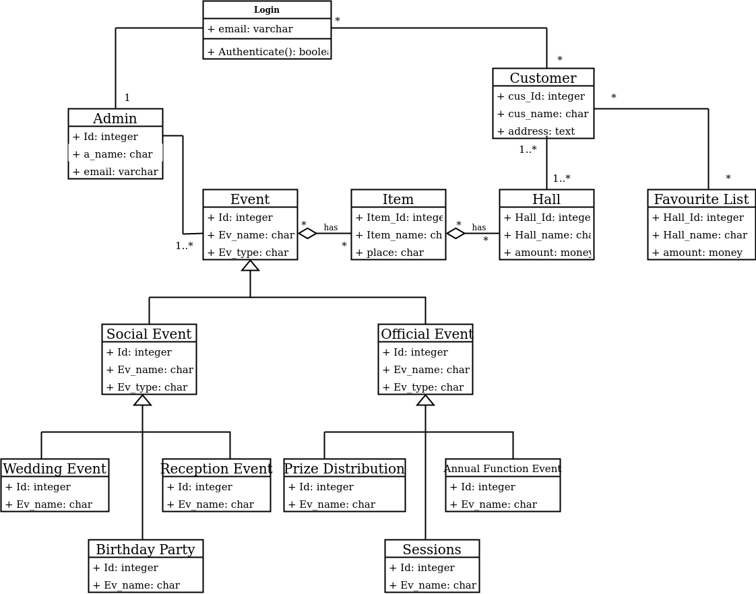

Admin Use Case

Diagram

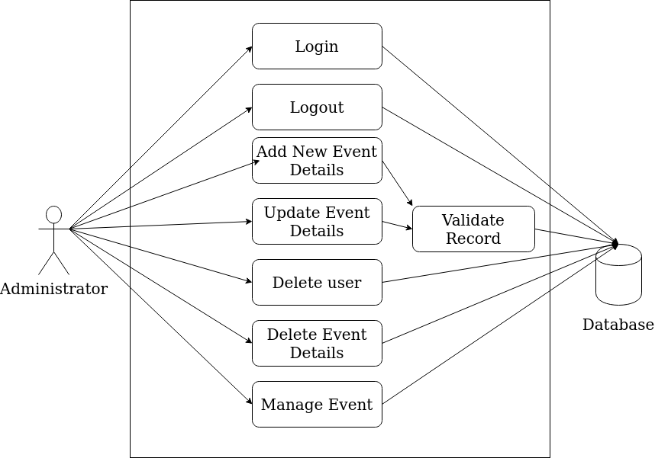

User Use Case

Diagram

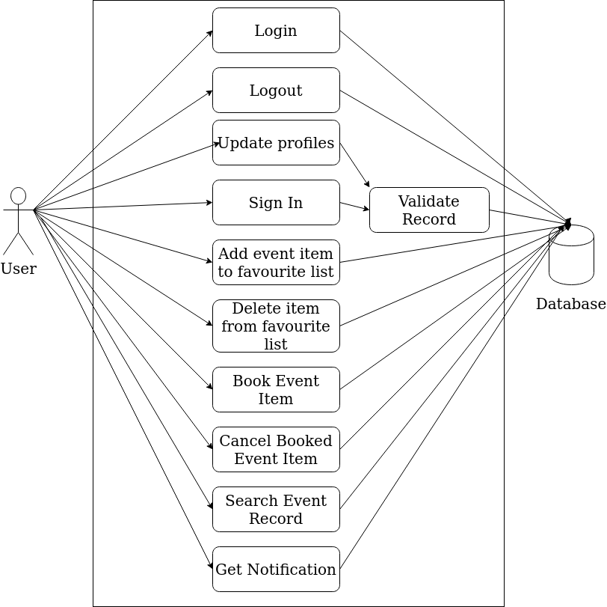

Activity Diagram

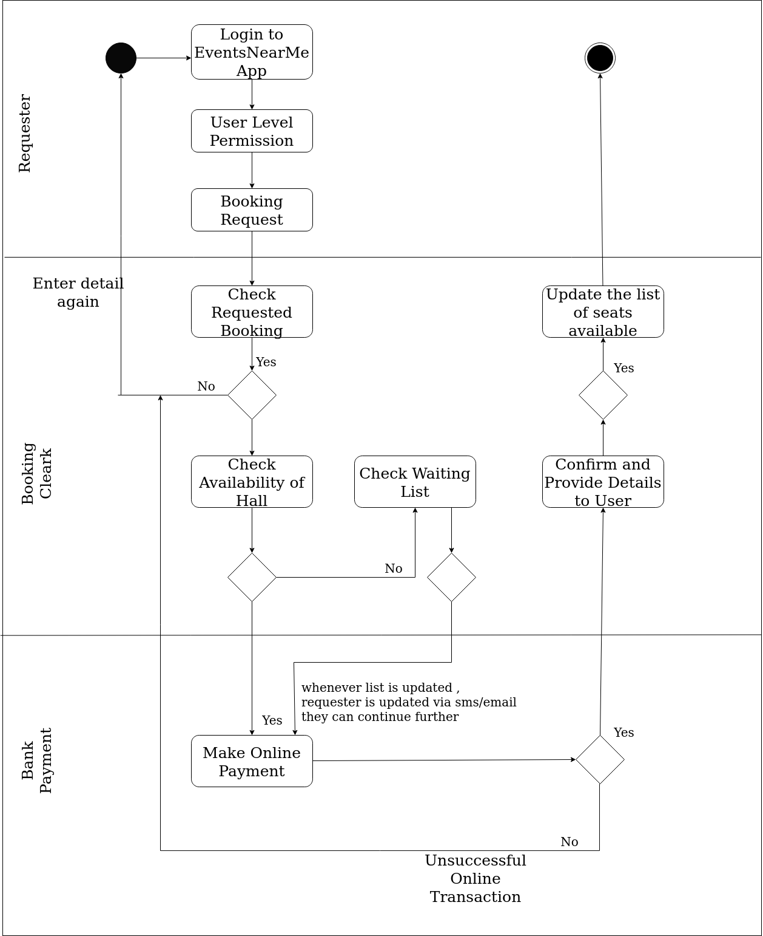

Sign Up/In Sequence Diagram

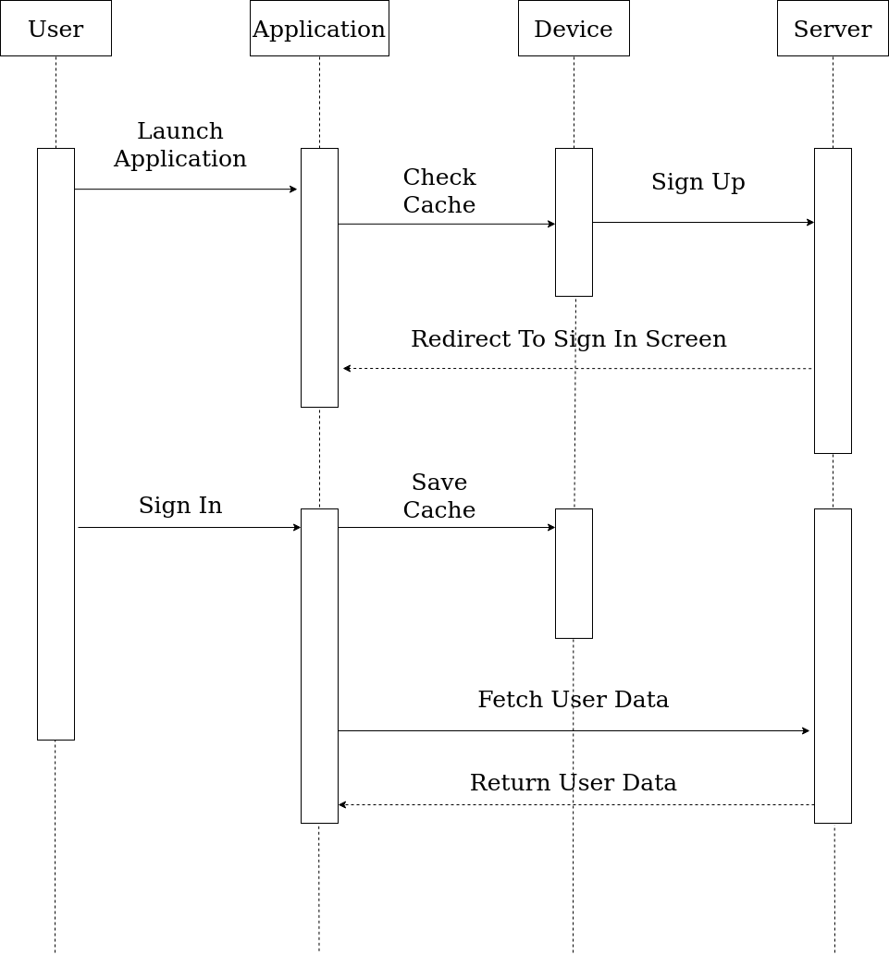

System Sequence Diagram

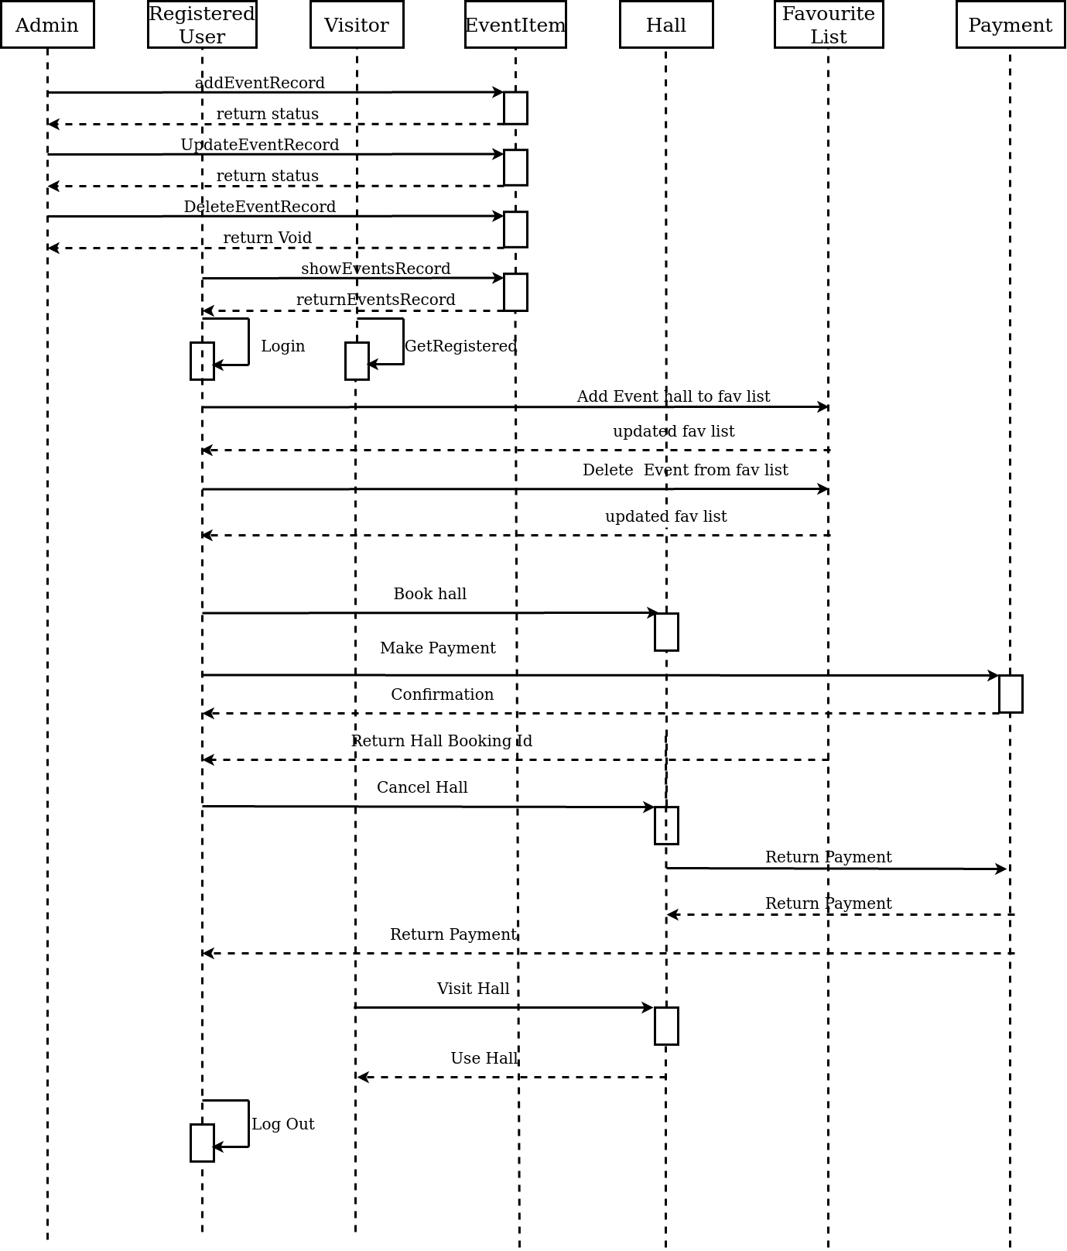

DATA DICTIONARY

JSON DATA =

1)

EventData = [

{

Event_id : int;

EventName : String,

EventDetails:Object,

}

2)

EventDetails=[

{

Hall_ID:int,

Hall_name:String ,

Hall_img:image,

open_time: time,

close_time : time,

area : String,

stats : boolean,//to check hall available or not

price : money,

rating : float ,

isVarifide : boolean,// to check hall is verified or not

map_location :{

latitude : double,

longitude : double,

address : text,

},

special_facilities :[

{

facility_type : boolean ,// to check now facility is available or not

facilityName : string

},

],

gallary : [

{

imgId :integer

imgName :image,

}

]

},

];

3)

Favourite =[

*\*EventDetails info\**

Hall_id:integer,

user_id:integer,

];

4)

UserProfile=[

user_id:integer,

user_name:string,

user_city:string,

user_country:string,

user_street_address:text,

user_email_id:varchar,

user_contact_num:number,

user_image:image,

user_profile_data:object,

];

App Screens



